Measuring blood glucose with haemogluco test strips

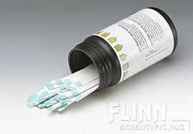

Image : teststrips

Step 1: Perform handhygiene (use handhygiene)

Step 2: Clean workfield (use table)

Step 3: Ask client to wash his hand with soap. (diaglog -> wash your hands please)

Step 4: Check expiration date of the teststrips (image1) (examin teststrips)

Step 5: Place lancet (see image2) within the pricking pen (combine lancet + pricing pen)

Step 6: Take teststrips out of the casing (decombine teststrip casing)

Step 7: put on gloves (pick up gloves -> use)

Step 8: Check if injectionspot is warm ( examine-> patient finger)

Step 9: Inject pricking pen on the side of the finger top (UseON pricking pen -> patient)

**Start animation sequence**

* Inject prickingpen on the side of the finger top -> right choice
* Inject pricking pen on top of the finger top -> wrong
* Inject needle in the nail of the patient -> wrong
* Leave

*If choice is right -> show animation, after animation show new dialog cirkel.*

***!!!Used pricking pen is removed from the players hands and spawned on the table!!***

Step 10: Do NOT push the vinger to get blood droplet.

* Do NOT push the vinger to get blood droplet -> right
* Push the vinger to get blood droplet -> wrong
* Pull the finger to get blood droplet-> wrong
* Leave

*If choice is right -> show animation, after animation show new dialog cirkel.*

Step 11: Whipe away the first blood droplet away with cloth (to ensure blood droplet is not contaminated.

*(cloth will be implemented within animation to make it easier, else the player has to quit animation to get cloth)*

* Whipe away the first blood droplet away with cloth -> right
* Collect blood droplet -> wrong
* Inject second time -> wrong
* Leave

*If choice is right -> show animation, after animation show new dialog cirkel.*

Step 12: Fill teststrip with the blood drop, filling the whole testfield of the teststrip. Do not smear the blood and do not touch the testfield of the teststrip.

* Fill teststrip with the blood drop, filling the whole testfield of the teststrip -> right
* Fill teststrip with the blood drop, NOT filling the whole testfield of the teststrip -> wrong
* Fill the teststrip with blood by smearing it over the the testfield -> worng
* Leave

Step 13: Wait for one minute and remove the blood of the testfield

* Wait for one minute and remove the blood of the testfield - > right
* Wait for one minute and leave the blood on the teststrip -> wrong
* Wait for 30 seconds and remove the blood of the testfield - > wrong
* Leave

Step 14: wait another minute

* Wait another minute ->right
* Wait another 30 seconds – >wrong
* Wait another 15 seconds ->worng
* Leave

*If choice is right -> stop animation sequence.*

Step 15: read the blood glucose values of the strips and compare them with the casting (combine casing with test strips, NO NEW object is made)

Step 16: write down the 2 values on a paper (Use paper)

Step 17: Throw teststrip in the needle trashcan (UseOn)

Step 18: Remove lancet from pricking pen (combine)

*!!Player has to pick up the combined pricking pen with lancet that spawned onto the table afeter step 9!!*

Step 17: Throw lancet in the needle trashcan (Use ON)

Step 18: Remove gloves (empty hand -> Use: Only possible at this step not during rest of game)

Step 19: Preform handhygiene (Use)

Step 20: Write down values (use)

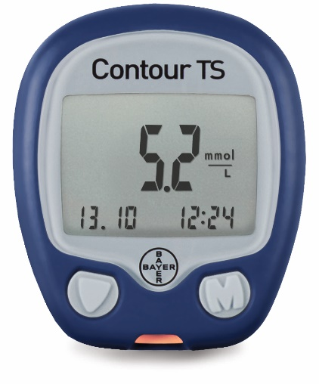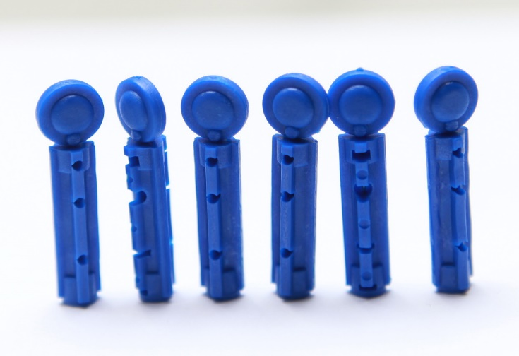

Image 3: Blood glucose measuring tool.

Image : Lancet